3. How to use the manual
This manual is designed to serve as a resource guide while planning for an eye hospital building, by providing practical tips to the clients (refers to ophthalmologists/administrators) and help them to:
- Scope the building size to reflect the patient volumes and other planned functions
- Develop a better understanding of the space requirements and key considerations for optimised space utilisation and layout in an eye care setting.
- Be adequately prepared to engage architects in the planning and subsequent design phase, which impacts the overall project design and development.
In terms of the hospital building requirements, a hospital building consists of three segments -
- clinical areas that allow a conducive environment to carry out clinical functions, specific to eye care. Example – Outpatient area, operating theatre complex, etc.
- patient and staff safety elements that needs to be incorporated
- Areas that are common to any hospital or other buildings that follow standard dimensions and design considerations. For example, inpatient rooms, common areas such as the lobby, amenities, toilets, building aesthetics felt as necessary
This manual intends to focus on the first two segments which require domain expertise derived from practical experience, to ensure a patient-centric layout design .
The other consideration is the applicability – The overall space requirements of an eye hospital project are determined by patient volumes, the scope of services, aesthetic considerations, and staff strength to manage it. Hence it would not be appropriate to discuss the ideal space requirements of a facility as a whole. On the other hand, what is consistent and applicable to any type of eye hospital are:
- high-level considerations that impact patient flow and the overall hospital design – eg. clinical work-flow, adjacencies, lighting, orientation, future expansion, support functions and safety considerations for patients and staff
- space considerations at a unit level – for example, dimensions and key considerations of an outpatient consultation room will remain the same irrespective of the hospital size while the number of consultation rooms may vary based on the outpatient volumes and services offered by the facility.
- Safety considerations for patients and staff utilising the facility
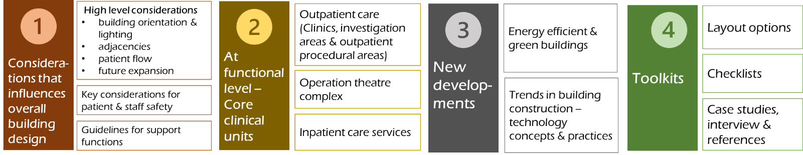
To achieve the above, the manual is divided into four sections as illustrated below.

Note: Section 3, New developments to be included later

Section 2, on clinical units largely discusses the design considerations at a functional unit level, though the checklists allow the clients to select the type and number of rooms to arrive at overall space requirements applicable to a specific hospital project. The same is applicable to determine other considerations such as lighting, water sourcing, power load, etc.
The manual can be navigated as per the reader’s need, either by approaching it sequentially or go to a specific section or a specific toolkit.
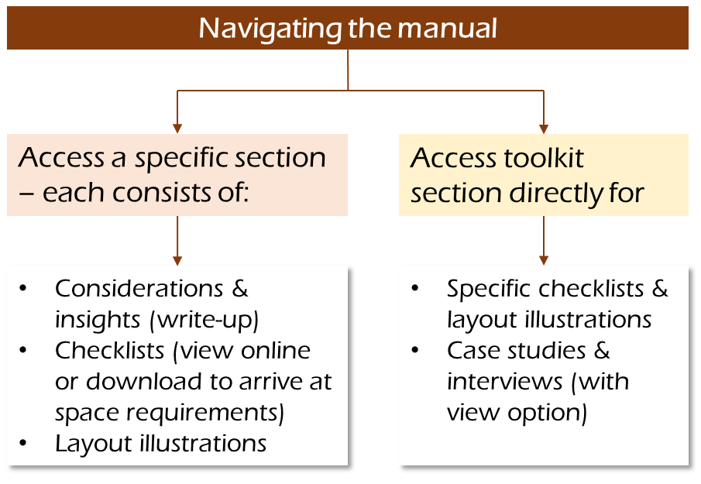
- Each section has a write-up discussing the key principles and toolkit consisting of checklists, layout illustrations, videos & references. Each toolkit comes with a description and how to use it.
- Checklists can be viewed online to know the details or downloaded to work out the space requirements applicable to individual settings. However, these checklists are not exhaustive but customizable by including the specific needs as per the local conditions and practices. We would also welcome suggestions for improving it.

